
Mini Project
QuizItOut: A Document-to-Quiz App Delivered Through a Jenkins CI/CD Pipeline
by
16010123318 Shweta Karandikar
16010123035 Alapan Barman
16010122309 Vraj Soni

For the subject
DevOps

Department of Computer Engineering
Academic Year 2026-27

Index
1. Introduction
1.1 Background
1.2 Problem Statement
1.3 Objectives, Scope
2. Tools and Technologies
2.1 Technology Stack
3. System Architecture
3.1 Overview
3.2 Application Flow
3.3 Components, Delivery Flow and Deployment
4. Implementation
4.1 The Application
4.2 Validation and the Fallback Cache
4.3 Version Control Workflow
4.4 Containerization
4.5 Jenkins Setup
4.6 CI/CD Pipeline
4.7 Deployment and Rollback
5. Security
6. Testing
6.1 Testing Strategy
6.2 Unit and API Tests
6.3 Retrieval Quality Gate
6.4 Smoke Test
6.5 Deliberate Failure Tests
7. Results
7.1 Pipeline Runs
7.2 Security Scan Results
7.3 Application Results
8. Limitations
8.1 Future Improvements
9. Conclusion
References

Abstract
QuizItOut turns an uploaded PDF, DOCX, PPTX, TXT or Markdown file into a multiple-choice quiz using a locally hosted large language model (Ollama running llama3). Every generated question is validated before it is shown: a schema check enforces four distinct options and a valid answer index, and a grounding check confirms that the model's evidence sentence really appears in the source document. If the model is unavailable, a hand-reviewed quiz is served for the known demo file only, matched by its SHA-256 fingerprint and clearly labelled as cached.
The application is delivered through a 10-stage Jenkins pipeline defined as code. Each push to GitHub triggers linting, 38 automated tests with an 80% coverage gate, a retrieval quality gate, a multi-stage Docker build, a Trivy vulnerability scan, a push of a git-SHA-tagged image to Docker Hub, a Docker Compose deployment, a smoke test and an automatic rollback to the last good version on failure.
On the final runs, test coverage was 99%, the retrieval hit-rate was 1.00 against a 0.80 threshold, and the shipped image had zero fixable HIGH or CRITICAL vulnerabilities after seven findings were fixed at their source. The report also states the project's limits honestly: it runs on one laptop, has no monitoring or staging environment, and validates evidence rather than answer correctness.

1. Introduction

1.1 Background
DevOps joins software development and operations through automation, shared ownership and fast feedback. Its core practice is a delivery pipeline: every code change is automatically built, tested and deployed, so problems are caught minutes after they are introduced instead of days later.
Large language models (LLMs) can now generate study material such as quiz questions. Running them locally, through tools like Ollama, keeps documents on the user's machine and avoids per-request API costs. LLM output is, however, unpredictable: it can be badly formatted or invented. That makes an LLM application a realistic test of a delivery pipeline, because the pipeline has to protect users from both code bugs and model behaviour.

1.2 Problem Statement
Students revise from lecture notes and slides, but writing practice questions by hand is slow. Generic AI chat tools can write questions, yet they give no guarantee that a question is based on the student's own material, and they send documents to a third-party service.
On the engineering side, a small team needs a way to change such an application safely. Without automation, a broken change, a vulnerable dependency or a failed deployment reaches users unnoticed, and recovering means remembering which version last worked.

1.3 Objectives
- Build a web application that converts an uploaded document into a validated multiple-choice quiz using a local LLM.
- Treat LLM output as untrusted input: validate its structure and check that its evidence is quoted from the document.
- Keep the application usable when the LLM fails, through a transparent, hash-keyed fallback.
- Automate testing with unit, API and quality-gate tests, enforced by an 80% coverage threshold.
- Containerize the application with a small, non-root, health-checked Docker image.
- Implement a Jenkins CI/CD pipeline as code that builds, tests, scans, publishes and deploys on every push.
- Deploy every build by its git SHA and roll back automatically when a deployment fails its smoke test.

1.4 Scope
In scope: document parsing (PDF, DOCX, PPTX, TXT, MD), chunking, local LLM question generation, validation, an optional topic-focused mode with hybrid search, a single-page web UI, automated tests, Docker images, a Jenkins pipeline, Trivy scanning, Docker Hub publishing, Docker Compose deployment and rollback.
Out of scope: user accounts and authentication, OCR for scanned PDFs, cloud hosting, Kubernetes, infrastructure as code, monitoring and alerting, and a separate staging environment. Section 8 explains how these would be added.

2. Tools and Technologies

2.1 Technology Stack
Layer | Tool | Role in QuizItOut
Language | Python 3.11 | All application, test and script code
Web API | FastAPI, Uvicorn | HTTP routes for upload, health and the demo endpoint
Data contract | Pydantic v2 | Validates LLM output and shapes API responses
Parsing | pypdf, python-docx, python-pptx | Extract plain text from uploaded files
LLM | Ollama + llama3 (8B) | Generates one question per text chunk, locally
Retrieval (topic mode) | sentence-transformers (all-MiniLM-L6-v2), FAISS, rank-bm25, cross-encoder (ms-marco-MiniLM-L-6-v2) | Hybrid dense + keyword search with reranking
Frontend | One static HTML file, plain JavaScript | Upload page and flashcard-style quiz, no build step
Version control | Git, GitHub | Source history, single source for Jenkins
Testing | pytest, pytest-cov, httpx, Ruff | Unit/API tests, coverage gate, linting
Containers | Docker (multi-stage, BuildKit), Docker Compose | Build, ship and run the app
CI/CD | Jenkins LTS (declarative pipeline) | Runs the 10-stage pipeline on every push
Security scan | Trivy (aquasec/trivy container) | Fails the build on fixable HIGH/CRITICAL CVEs
Registry | Docker Hub | Stores images tagged by git SHA and latest
Host | macOS (Apple M5, 16 GB), Docker Desktop | Runs Jenkins, Ollama and the deployed app

2.2 Why These Tools
- Jenkins over GitHub Actions. The course allows either. Jenkins runs on the same machine as Docker Desktop and Ollama, so the pipeline can build images, deploy them and smoke-test them locally without exposing the laptop to the internet. The Jenkinsfile lives in the repository, so the pipeline is versioned like code.
- Docker multi-stage builds. One Dockerfile produces a test image (with pytest, Ruff and tests) and a smaller runtime image without them. Tests run on exactly the same base layers that ship.
- Docker Compose for deployment. One file declares the image, port and environment. The image tag comes from an environment variable, so Jenkins can deploy any exact version and roll back by changing one value.
- Trivy. Free, fast, runs as a container (nothing to install), and scans both OS packages and Python packages.
- Ollama with llama3. Runs offline on a laptop, keeps documents private, and offers a JSON output mode. A cloud API would add cost and send student documents to a third party.
- FastAPI + Pydantic. The same Pydantic model validates LLM output and defines the API response, so the two can never drift apart.
- pytest with a fake LLM. The generator receives the LLM client as an argument (dependency injection), so tests pass in a FakeLLM and never make network calls. Tests are fast and deterministic.
- No LangChain or similar frameworks. The pipeline is small enough to write directly, which keeps the image smaller and every step explainable.

3. System Architecture

3.1 Overview
QuizItOut has two separate flows. The application flow takes an uploaded file and returns a quiz. The delivery flow takes a git push and ends with a new, verified version running. They meet at one point: the Docker image that the pipeline builds is the application users run.

3.2 Application Flow (upload to quiz)
The upload passes through six components in order. Only one of them, the LLM client, makes a network call; every other step is a pure function that can be tested in isolation.
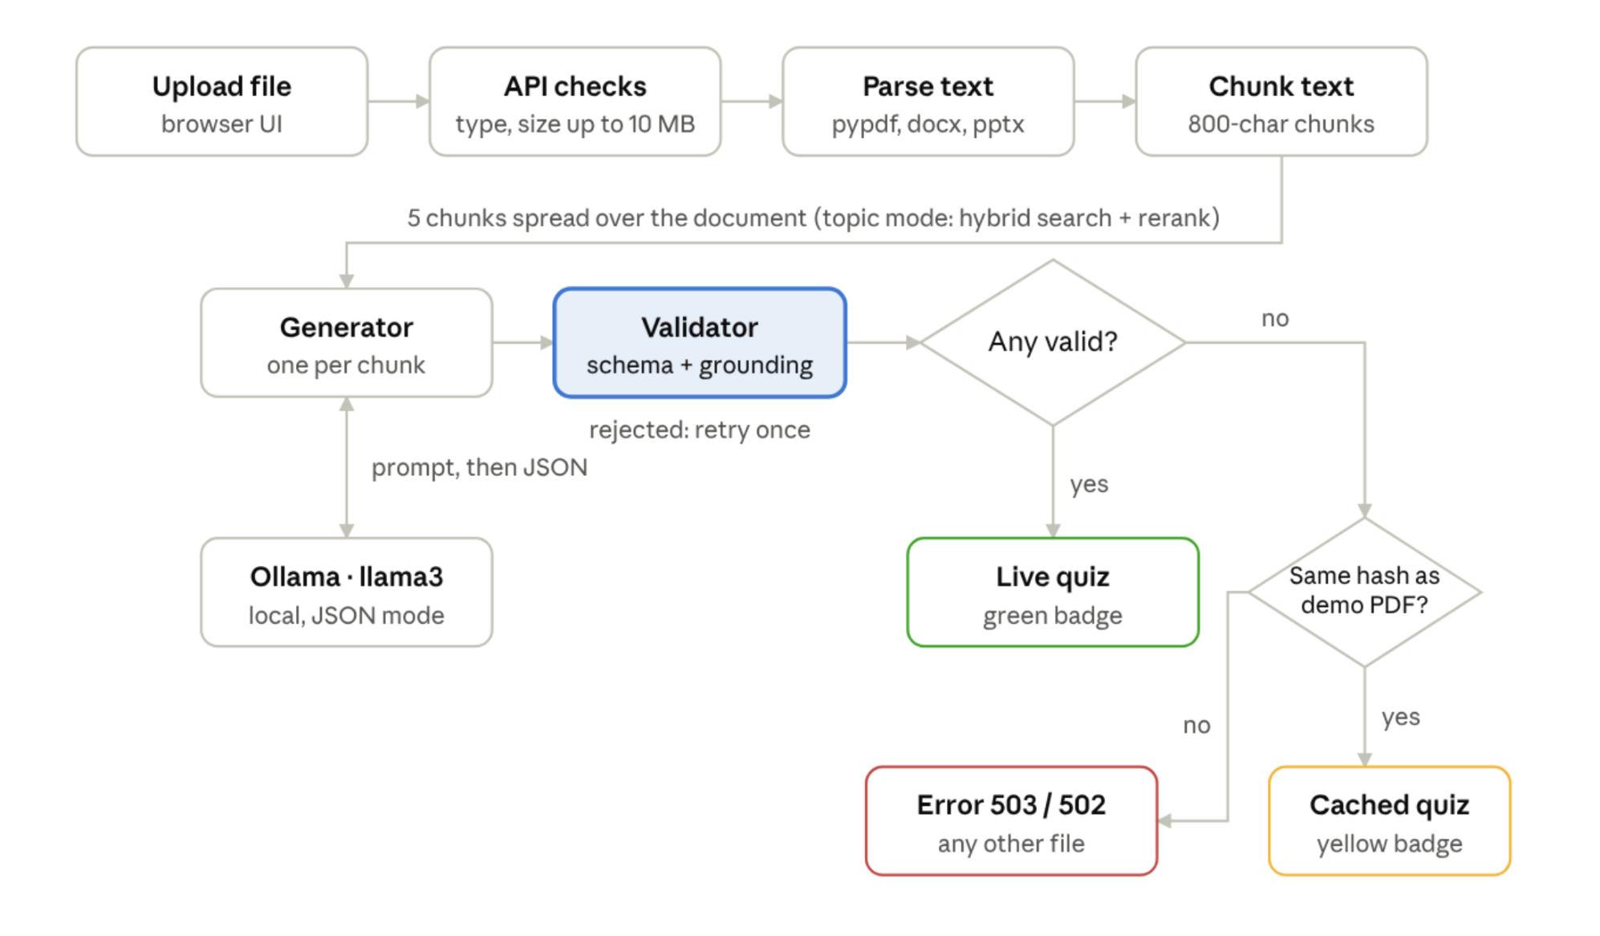
Figure 1: Application flow from upload to quiz.
A live quiz needs at least one question that passes the validator; only when there are none does the app check whether the upload is the demo PDF.

3.3 Components
Component | File | Responsibility
API layer | app/main.py | Validates the upload (type, size), wires the steps together, picks the status code. Contains no business logic.
Settings | app/config.py | Reads all settings from environment variables (12-factor style)
Data contract | app/schemas.py | MCQ (question, 4 options, answer index, evidence) and QuizResponse (source: live or cached)
Parsers | app/parsers.py | Maps each file extension to a text extractor; rejects files with no text
Chunker | app/rag/chunker.py | Splits text into ~800-character chunks with 100-character overlap; picks chunks evenly across the document
Retriever | app/rag/retriever.py | Topic mode only: FAISS + BM25 hybrid search fused with Reciprocal Rank Fusion, then cross-encoder rerank
LLM client | app/quiz/llm.py | The only network call: sends the prompt to Ollama in JSON mode at temperature 0.3
Generator | app/quiz/generator.py | One question per chunk, one retry on a rejected answer
Validator | app/quiz/validator.py | Schema check + grounding check
Fallback | app/quiz/fallback.py | Serves the reviewed cache only when the upload's SHA-256 matches the demo file
UI | app/static/index.html | Landing page with drag-and-drop upload; one question per card, evidence shown after answering, score screen

3.4 Delivery Flow (push to running app)
Jenkins polls GitHub every two minutes. A new commit on main starts the pipeline; each stage must pass before the next runs. A failure before deployment leaves the current version running. A failure after deployment triggers an automatic rollback to the last version that passed every stage.
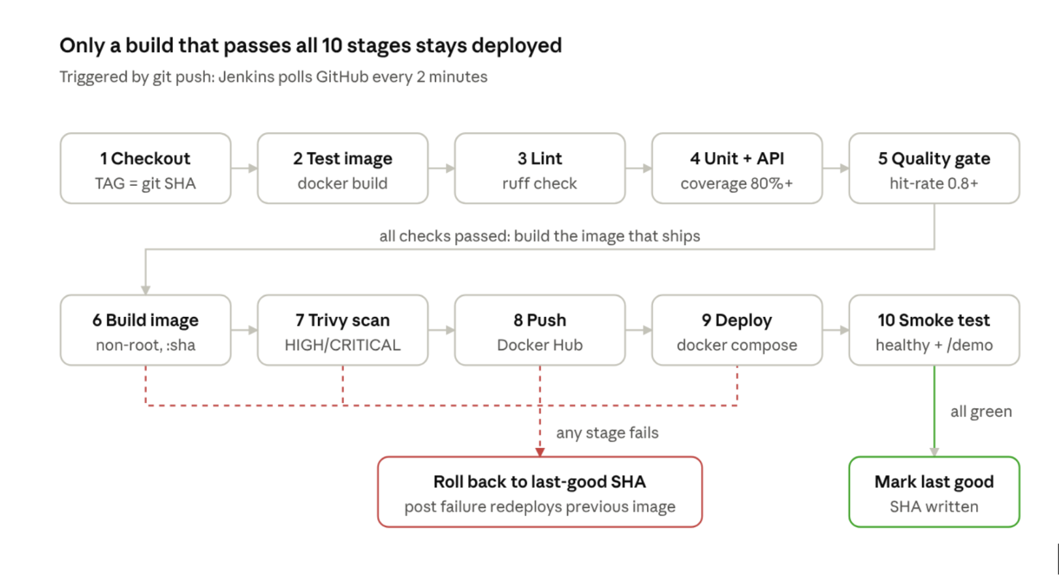
Jenkins pipeline · 10 stages, success and rollback paths
Figure 2: Jenkins CI/CD pipeline with success and rollback paths.
Stages run in order and stop at the first failure; the failure path always redeploys the last SHA that passed all ten stages.

3.5 Deployment Environment
All services run on one macOS laptop. Jenkins runs as a Homebrew service on port 8080 and uses Docker Desktop directly. Ollama runs natively on the Mac, so it can use the Apple GPU (Metal). The deployed app container listens on port 8000 and reaches Ollama through host.docker.internal. Docker Hub is the only external service besides GitHub.

4. Implementation

4.1 The Application
Parsing and chunking. A dictionary maps each extension to a parser, so adding a format means one function and one entry. Text is split on paragraph boundaries into chunks of at most 800 characters, with a 100-character overlap so an idea cut at a boundary still appears whole in one chunk. The 3-page demo PDF becomes 17 chunks.
Coverage, not retrieval. A quiz has no question to search for; it should cover the whole document. pick_spread therefore takes chunks at equal distances through the document, one question per chunk. Retrieval is used only in topic mode, when the user asks for questions on a specific subject.
Generation. Each chunk is sent to llama3 with a prompt requiring JSON with four keys: question, options, answer_index and source_snippet (one sentence copied word for word as evidence). The prompt also requires exactly one correct option and three options that are false according to the passage. Temperature 0.3 keeps output stable.
Figure 3: QuizItOut landing page with the document upload area.
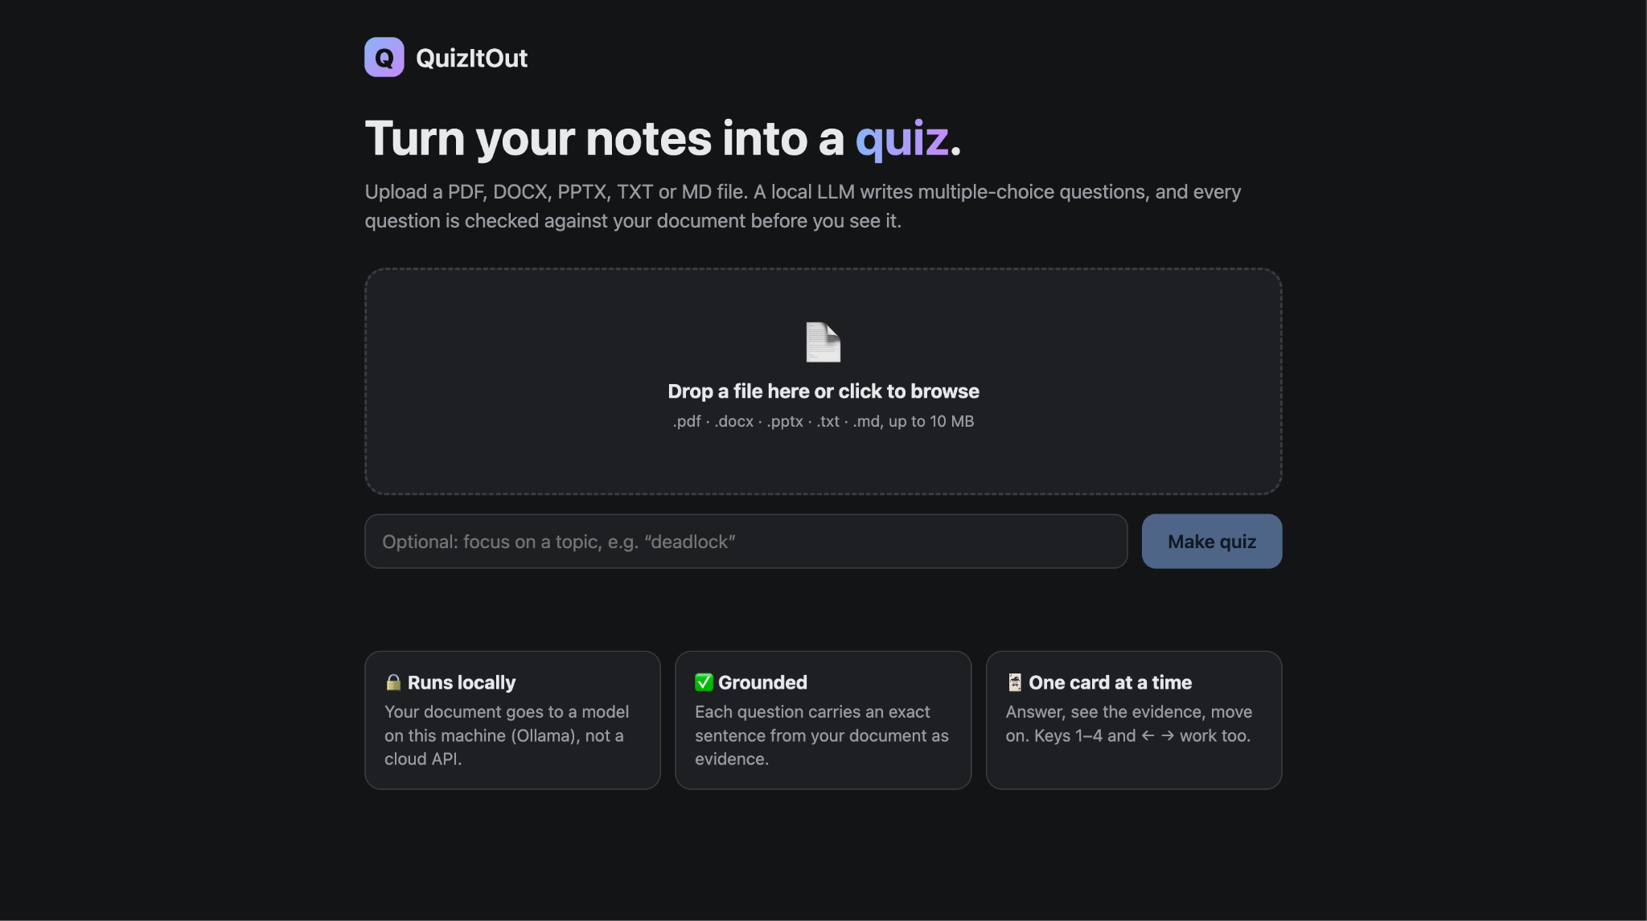
Figure 4: A quiz card after answering, showing the "generated live" badge and the evidence sentence.
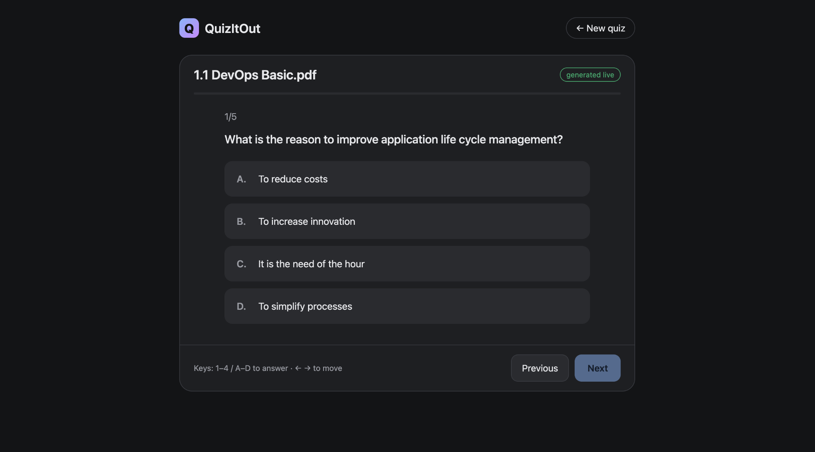

Figure 5: Results screen with the final score.
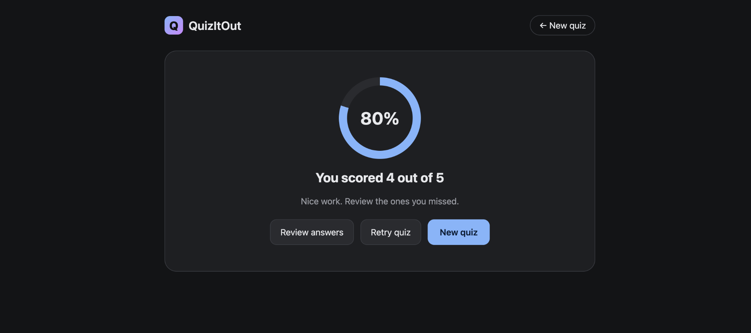

4.2 Validation and the Fallback Cache
LLM output is treated like user input: untrusted. Each answer passes two checks before it reaches the user.
- Schema (Pydantic): a question string, exactly 4 distinct options, answer_index from 0 to 3. Anything else raises a validation error.
- Grounding: the source_snippet must appear in the chunk, ignoring case and whitespace. An invented quote is rejected.
A rejected answer is retried once; a second rejection skips that chunk.
Fallback. data/demo/demo_quiz.json holds 5 questions generated by the real pipeline, reviewed by hand, and stored with the SHA-256 hash of demo_doc.pdf. The rules are:
Situation | Response
At least 1 valid live question | 200, source: "live" (green badge)
No live questions, upload's SHA-256 matches the demo file | 200, source: "cached" (yellow badge)
No live questions, other file, Ollama unreachable | 503 "Quiz model unreachable"
No live questions, other file, only invalid answers | 502 "no valid questions"
Unsupported type / file over 10 MB / no extractable text | 400 / 413 / 422

Figure 6: Quiz served from the reviewed cache ("cached" badge) after uploading the demo PDF with Ollama stopped.
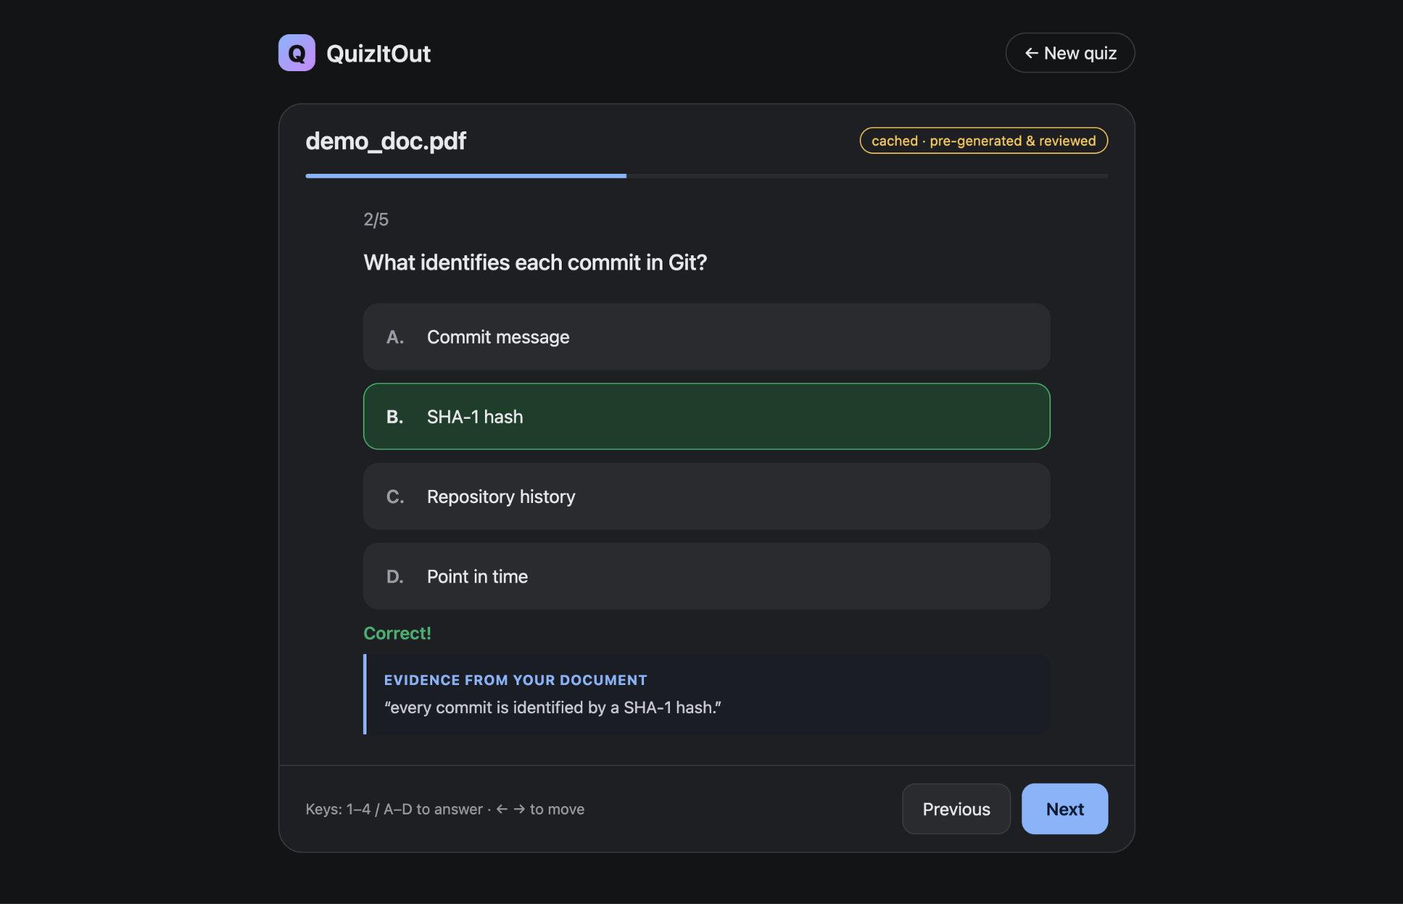

4.3 Version Control Workflow
The repository is hosted at github.com/shweta1275/QuizItOut on a single main branch. Work was committed phase by phase (phase 1: skeleton, config, schemas through phase 8: README, setup/demo checklist, project explanation), followed by fix commits found by the pipeline.
Figure 7: GitHub repository home page.
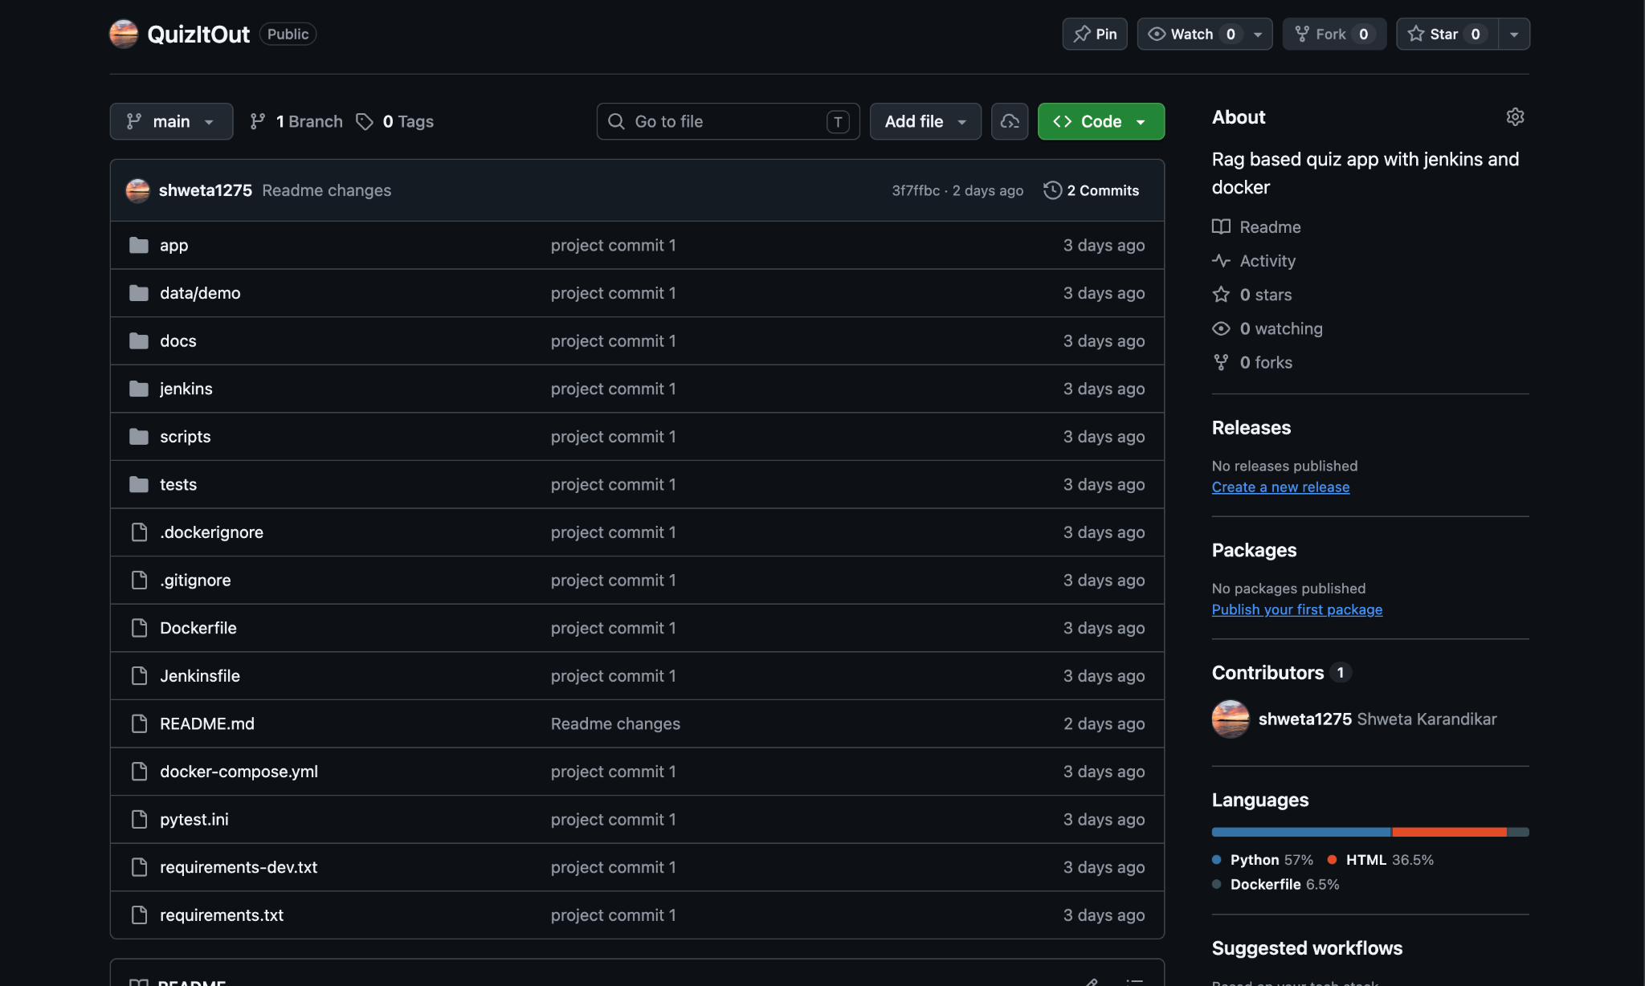

4.4 Containerization
One Dockerfile defines three stages:
Stage | Contents | Shipped?
base | Python 3.11 slim, patched OS packages, CPU-only PyTorch, requirements, both retrieval models baked in, app code and demo data | Shared by both
test | base + pytest, Ruff, tests, scripts | No: used only by the pipeline
runtime | base + non-root appuser, pip removed, HEALTHCHECK, Uvicorn command | Yes
Key decisions:
- Layer order for caching. requirements.txt is copied and installed before the code, so a code change rebuilds only the last layers, not the multi-gigabyte dependency layer.
- CPU-only PyTorch first. Installing it from the PyTorch CPU index stops sentence-transformers from pulling the much larger CUDA build.
- Models baked in at build time. The container starts without downloading anything, and models are made readable for the non-root user.
- BuildKit pip cache mount. Downloaded wheels stay on the build host, not in the image, so changing a requirement does not re-download PyTorch.
- Non-root and pip-free runtime. The app runs as appuser; pip is uninstalled from the runtime image (Section 5).
- HEALTHCHECK. The container reports healthy only when GET /health succeeds. The smoke test reads this status.
Runtime image. The final stage runs as non-root appuser, has pip removed, and includes a HEALTHCHECK that calls /health every 10 seconds, so Docker marks the container healthy only when the app responds.
Deployment. docker-compose.yml defines one service whose image tag comes from IMAGE_TAG. Setting it to a git SHA deploys that exact version, which is also how rollback works.

Figure 9: Running container quizitout-app-1 with status "healthy" (Docker Desktop or docker ps output).
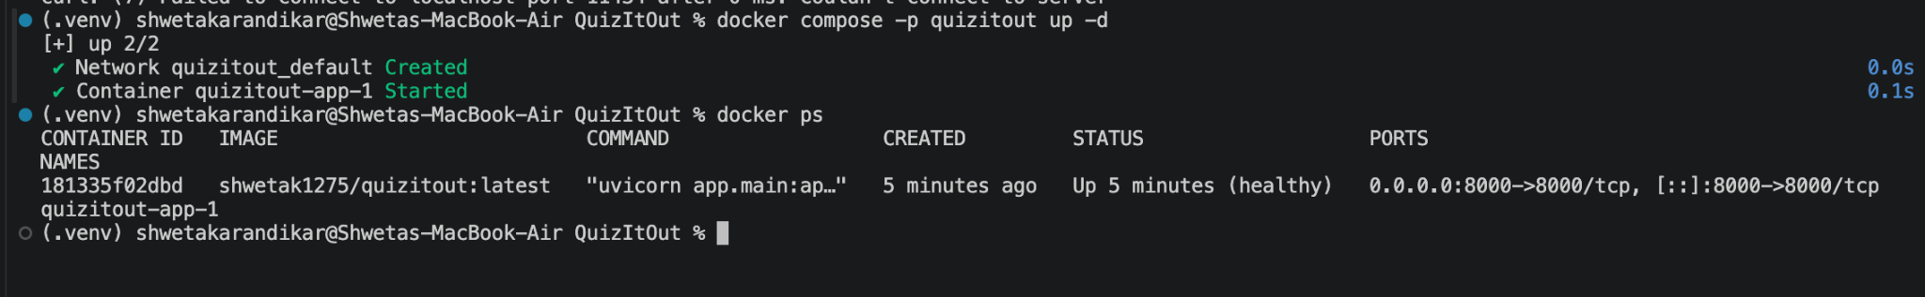

4.5 Jenkins Setup
Jenkins LTS runs as a Homebrew service on the host Mac at localhost:8080. The job quizitout is a Pipeline job configured as Pipeline script from SCM: Git, the GitHub URL, branch */main, script path Jenkinsfile. The trigger is Poll SCM with schedule H/2 * * * * (a webhook would need a public URL).
Two host-specific issues were solved in the Jenkinsfile itself:
- Homebrew starts Jenkins with PATH=/usr/bin:/bin:/usr/sbin:/sbin, which does not include Docker Desktop's ~/.docker/bin. The pipeline's environment block prepends it.
- The Push stage logs in with its own DOCKER_CONFIG folder so it does not overwrite Docker Desktop's login, and pins DOCKER_HOST first because an empty config loses the Docker context.
Figure 10: Jenkins job configuration: Pipeline script from SCM, branch */main, Poll SCM trigger.
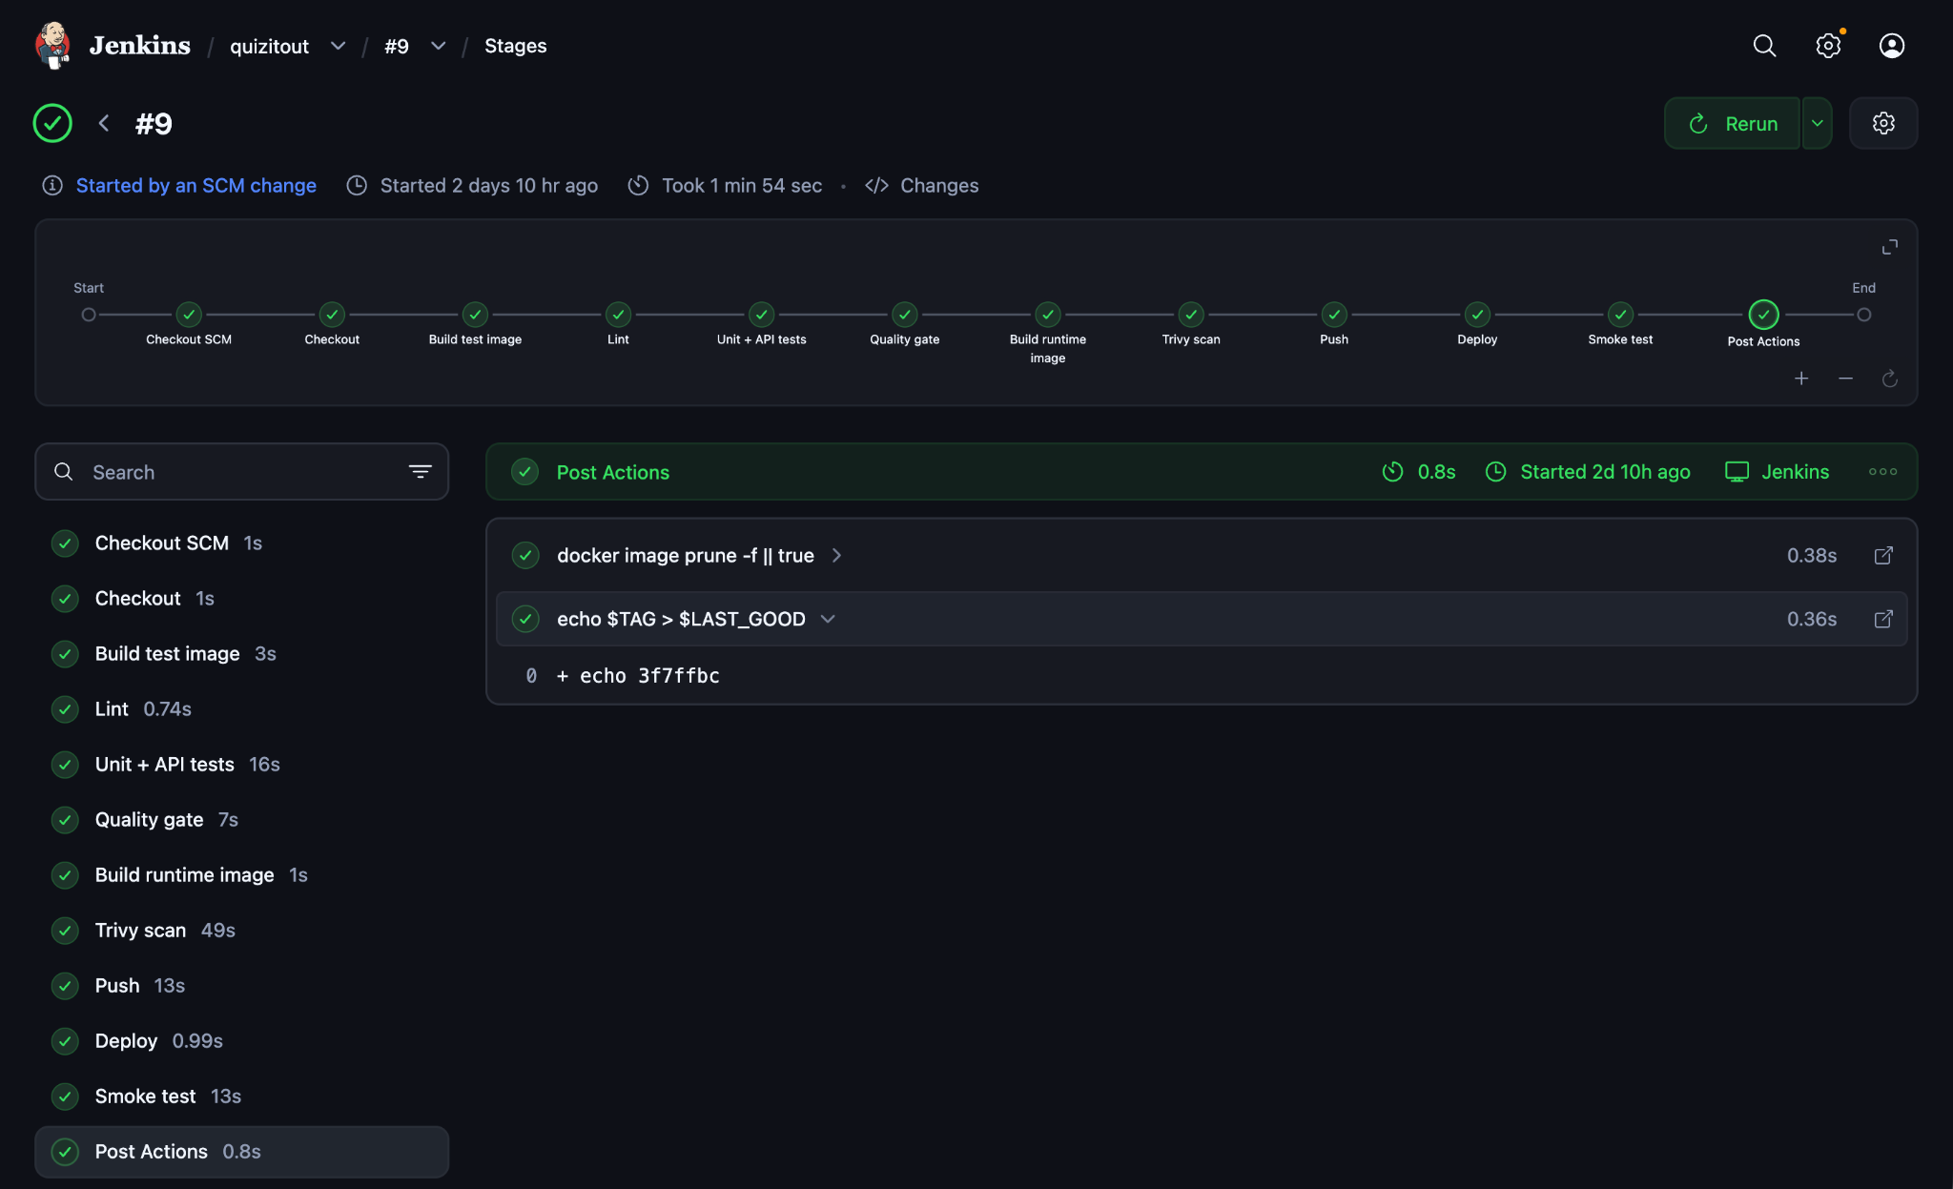

4.6 CI/CD Pipeline
The declarative Jenkinsfile defines 10 stages. disableConcurrentBuilds() stops two deployments from racing.
# | Stage | What it does | Fails when
1 | Checkout | Clones the repo; TAG = git rev-parse --short HEAD | Repo or branch unreachable
2 | Build test image | docker build --target test | Dockerfile or dependency broken
3 | Lint | ruff check app tests scripts inside the test image | Unused imports, syntax or style errors
4 | Unit + API tests | pytest --cov=app --cov-fail-under=80 | Any test fails or coverage below 80%
5 | Quality gate | Retrieval hit-rate@3 on a golden set | Hit-rate below 0.80
6 | Build runtime image | Tagged :<sha> and :latest | Build error
7 | Trivy scan | --severity HIGH,CRITICAL --ignore-unfixed --exit-code 1 | Any fixable HIGH/CRITICAL CVE
8 | Push | Logs in with the token, pushes both tags | Wrong or read-only token
9 | Deploy | IMAGE_TAG=$TAG docker compose -p quizitout up -d | Pull or configuration error
10 | Smoke test | Waits up to 60 s for healthy, then calls /api/quiz/demo | App unhealthy or endpoint failing
Lint, tests and the quality gate run inside the test image rather than on the Jenkins workspace, so they use exactly the dependencies that ship and need no Python on the Jenkins host.

4.7 Deployment and Rollback
Every image is tagged with the short git SHA, so each running container maps to one exact commit; latest is only a convenience. After a successful run, the post { success } block writes the SHA to $JENKINS_HOME/quizitout_last_good. If any stage fails, post { failure } redeploys that SHA:
post {
success { sh 'echo $TAG > $LAST_GOOD' }
failure {
sh '''
if [ -f "$LAST_GOOD" ]; then
echo "Rolling back to $(cat $LAST_GOOD)"
IMAGE_TAG=$(cat $LAST_GOOD) docker compose -p quizitout up -d
else
echo "No previous good version to roll back to"
fi
'''
}
always { sh 'docker image prune -f || true' }
}
A failure before Deploy re-applies the version that is already running, so it is harmless. A failure in the Smoke test replaces the broken container with the last good one.
Figure 13: Docker Hub tags page showing the git-SHA tag and latest.
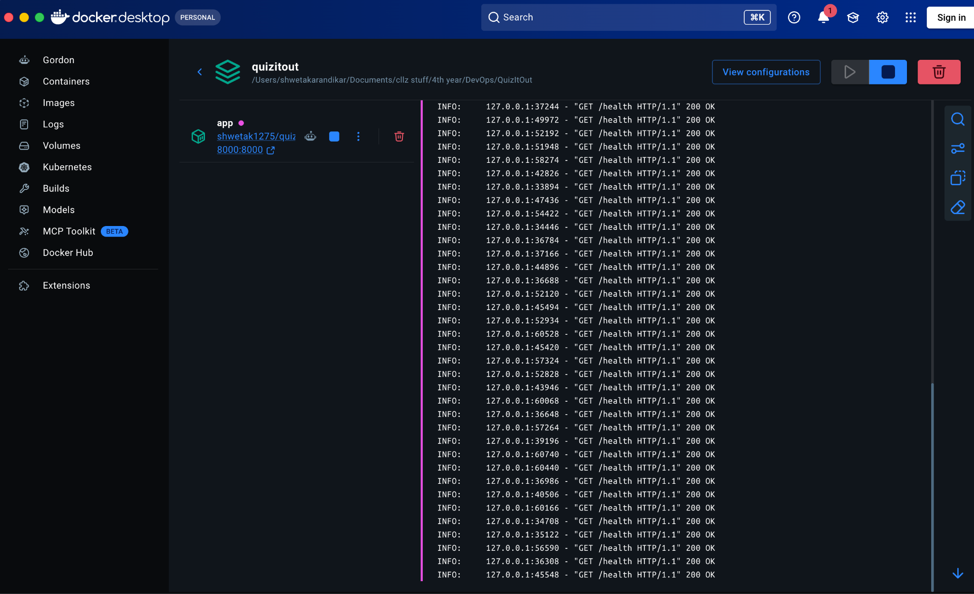
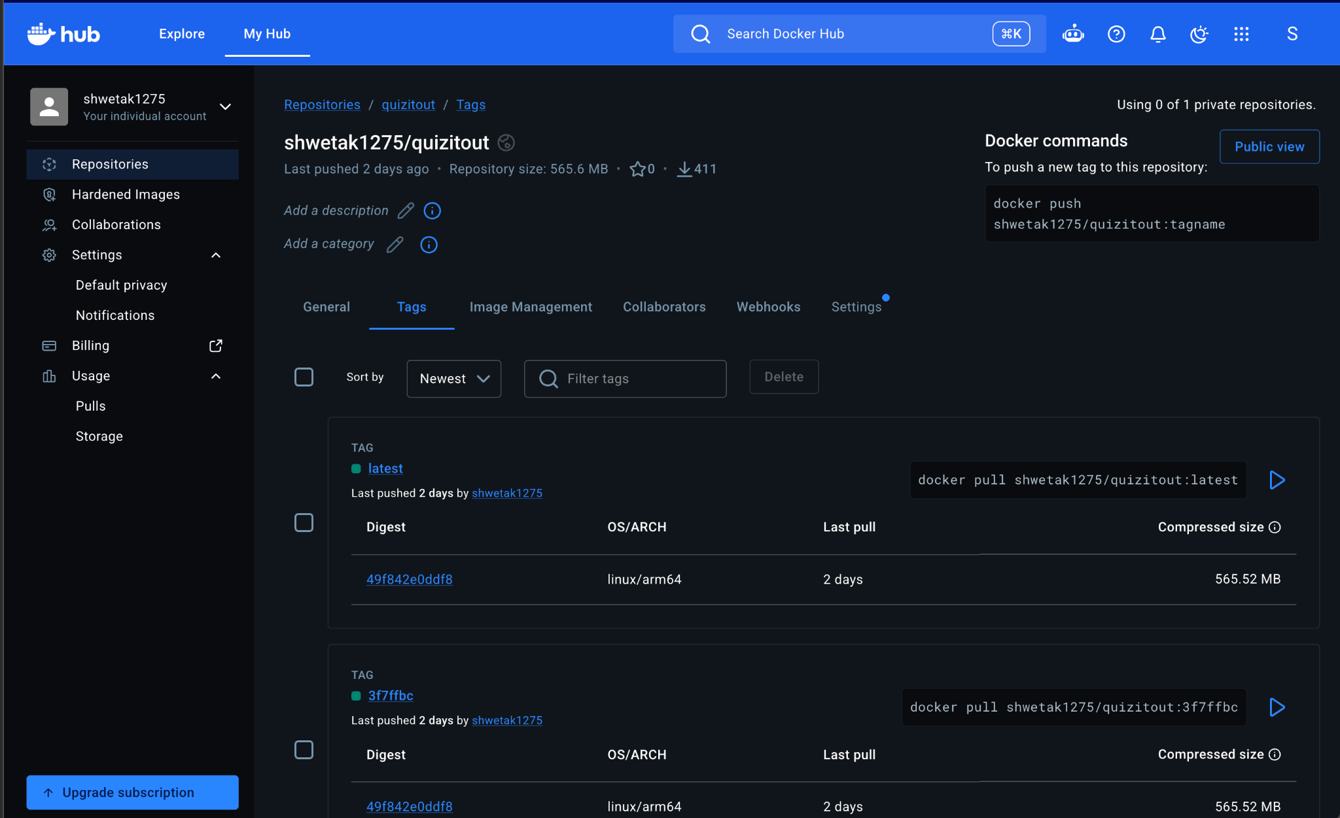

5. Security
Security is enforced by the pipeline, not left to manual review: a build with a fixable HIGH or CRITICAL vulnerability cannot be pushed or deployed.
- Vulnerability scanning (Trivy). Stage 7 scans the exact image that will ship, covering Debian packages and Python packages. --ignore-unfixed skips CVEs with no available patch, since no action is possible; .trivyignore is reserved for findings that genuinely cannot be fixed, each with a written reason. It is currently empty.
- Fix at the source, never by ignoring. Seven HIGH findings appeared during development and all were fixed in the Dockerfile (Section 7.2).
- Least privilege in the container. The runtime image runs as the non-root appuser. pip, setuptools' build tools and the test toolchain are absent from it, reducing what an attacker could use.
- Secrets. The Docker Hub credential is a scoped access token (Read & Write), not the account password. It lives only in the Jenkins credentials store, is injected with credentials('dockerhub'), is masked as **** in logs, and is used inside single-quoted shell blocks so Groovy never interpolates it into the log. A separate token was created for Jenkins, so it can be revoked without affecting Docker Desktop.
- Untrusted LLM output. Model text is validated by schema and grounding before use, and the frontend inserts it with textContent only, never innerHTML, which prevents cross-site scripting through generated text.
- Input limits. Uploads are restricted by extension and to 10 MB; files with no extractable text are rejected with 422.
- Documents stay local. The LLM runs on the same machine, so uploaded documents are never sent to a third-party AI service.
Figure 15: Trivy scan output in the Jenkins console (no fixable HIGH or CRITICAL vulnerabilities).
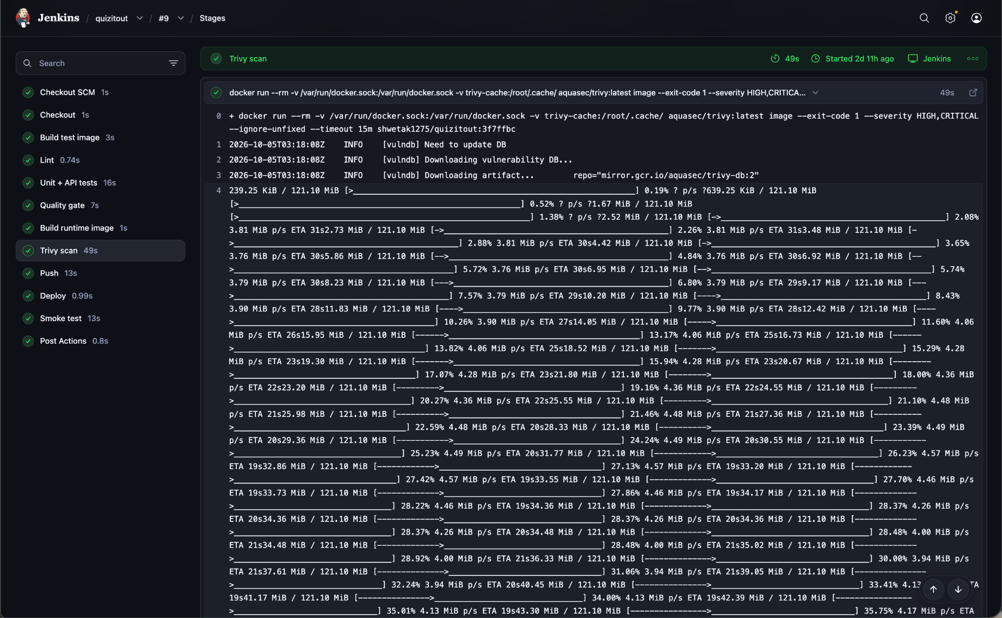
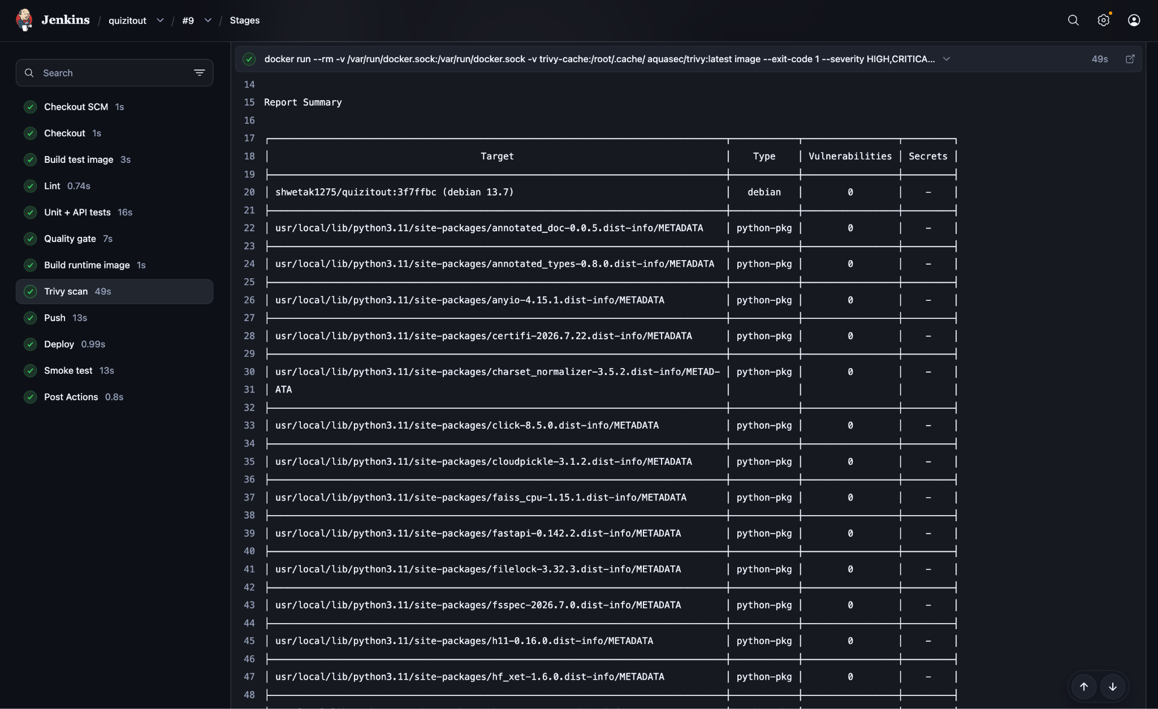

6. Testing

6.1 Testing Strategy
Testing has three layers, all run automatically by the pipeline, plus a smoke test after deployment. The real LLM is never called in automated tests: it is slow, needs a running model and gives different output each time. Because the generator receives its LLM client as an argument, tests pass in a FakeLLM that returns prepared answers, or a DownLLM that simulates Ollama being unreachable.
Layer | What it checks | Tool | Pipeline stage
Static analysis | Unused imports, syntax and style issues | Ruff | 3 Lint
Unit tests | Parsers, chunker, validator, generator, LLM client, retriever | pytest | 4 Tests
API tests | Every route and status code, including the fallback rules | pytest + FastAPI TestClient | 4 Tests
Coverage gate | At least 80% of application lines executed by tests | pytest-cov | 4 Tests
Quality gate | Retrieval finds the right passage for known questions | scripts/quality_gate.py | 5 Quality gate
Security gate | No fixable HIGH/CRITICAL CVEs | Trivy | 7 Trivy scan
Smoke test | The deployed container is healthy and serves requests | Docker healthcheck + HTTP call | 10 Smoke test

6.2 Unit and API Tests
The suite has 38 tests across 7 files. Some representative cases:
Test file | Example cases
test_parsers.py | TXT, DOCX and PPTX files created inside the test (no binary fixtures); the demo PDF parses; .exe and empty files are rejected
test_chunker.py | No chunk exceeds the size limit; one huge paragraph is split; pick_spread covers the whole document
test_validator.py | A valid question passes; answer index 7, duplicate options, missing keys and an invented evidence sentence are each rejected
test_generator.py | One question per chunk; retries after a garbage answer; gives up after the retry limit
test_llm.py | Ollama errors become LLMUnavailable; bad JSON from the model becomes an empty answer
test_retriever.py | RRF ranks an item high in both lists first; hybrid search and the rerank path find the right chunk
test_api.py | Health; 400, 413, 422, 502 and 503 paths; live quiz; cache served for the matching file; cache never served for a different file; PREFER_CACHE; demo endpoint
Result on every final run: 38 passed, coverage 99.19% (246 statements, 2 missed). The gate fails the build below 80%.
Figure 16: Test and coverage report in the Jenkins console (38 passed, 99% coverage). 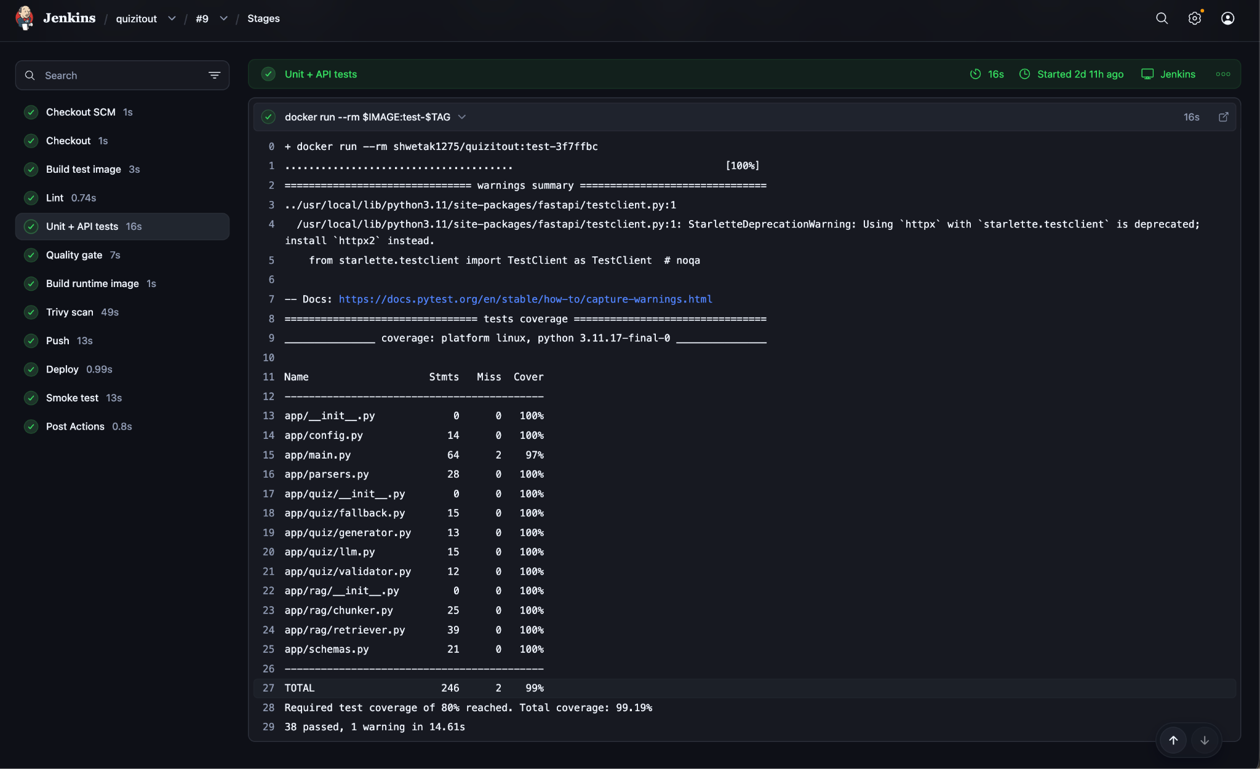

6.3 Retrieval Quality Gate
Unit tests prove the code runs; they do not prove retrieval is good. The quality gate uses a one-page golden document of operating systems and networking notes (tests/golden/notes.txt) and 8 questions, each with a phrase that must appear in the correct passage. For each question the retriever returns its top 3 chunks; a hit means the phrase is among them.
\text{hit-rate@3} = \frac{\text{questions whose answer passage is in the top 3}}{\text{total questions}} \geq 0.80
Result: 8 of 8 hits, hit-rate@3 = 1.00. A future change to chunk size or the embedding model that hurts retrieval would fail this stage.
Figure 17: Quality gate output (8 hits, hit-rate@3 = 1.00). [Add screenshot here]

6.4 Smoke Test
After deployment, the pipeline polls the container's Docker health status every 3 seconds for up to 60 seconds. Once it is healthy, it calls GET /api/quiz/demo inside the container and requires a successful response. Any failure triggers the rollback in Section 4.7.

6.5 Deliberate Failure Tests
To prove that each gate actually stops bad changes, the following failures can be introduced on purpose:
Change introduced | Expected result
A test assertion broken (answer_index 7 changed to 0 in a rejection test) | Red at stage 4; Push and Deploy skipped; the previous version keeps running
tests/test_api.py deleted | Red at stage 4: coverage below 80%
A known vulnerable package (jinja2==2.10) added | Red at stage 7 with a CVE table
HEALTHCHECK pointed at a wrong port | Green until stage 10, then "App never became healthy" and automatic rollback to the last good SHA
Ollama stopped, demo PDF uploaded | source: cached, yellow badge; any other file returns 503
The last case was verified with the published Docker Hub image and the LLM address deliberately set to a dead endpoint: the demo PDF returned 200 with 5 cached questions, and a different file returned 503.

7. Results

7.1 Pipeline Runs
Seven of the nine Jenkins runs succeeded. Both failures were stopped before deployment, so a broken version never ran. Six runs were started automatically by a git push (Poll SCM), not by clicking Build Now.
Build | Commit | Trigger | Result | Duration | What happened
#9 | 3f7ffbc | Push | Success | 1.9 min | README changes deployed
#8 | fb0d0f1 | Manual | Success | 1.1 min | Team commit built and deployed
#7 | (none) | Push | Failure | 0.0 min | Checkout failed: the main branch was briefly missing on GitHub during a repository change; nothing built or deployed
#6 | 9c0a623 | Push | Success | 1.2 min | New UI (demo button removed) deployed automatically
#5 | 244a13c | Push | Success | 1.0 min | README startup guide
#4 | e4a16a6 | Manual | Success | 1.2 min | Re-run of #3
#3 | e4a16a6 | Push | Success | 21.9 min | Longest run
#2 | b455a1e | Push | Success | 6.9 min | First fully green run: image :b455a1e on Docker Hub, deployed, healthy
#1 | fc7f63b | Manual | Failure | 1.0 min | Stages 1 to 7 green; failed at Push (Docker context issue, Section 8.1); nothing deployed
After the first run, a typical build took 1 to 2 minutes, because unchanged Docker layers (Python, PyTorch, models) are reused from cache and only the application layers are rebuilt.

Figure 18: Jenkins build history for the quizitout job.
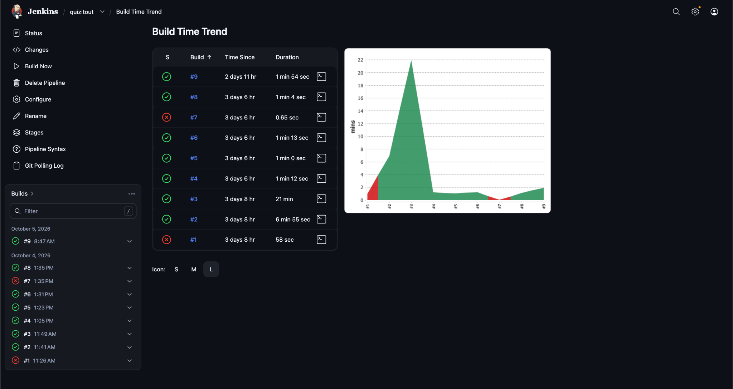
Figure 19: A failed build: the failing stage in red and the later stages skipped.
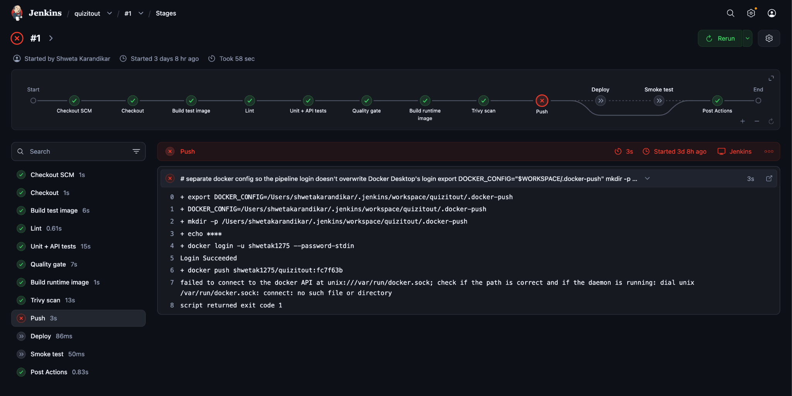

7.2 Security Scan Results
Trivy found 7 fixable HIGH vulnerabilities across two scans; all were fixed at the source, and the final image scans clean with no ignore list.
Scan | Finding | Root cause | Fix
1 | libpcre2-8-0 (CVE-2026-103111) | Outdated Debian package in python:3.11-slim | apt-get upgrade -y in the base stage
1 | wheel 0.45.1 (CVE-2026-24049), jaraco.context 5.3.0 (CVE-2026-23949) | Old copies vendored inside the base image's setuptools | Upgrade pip, setuptools and wheel before installing anything
2 | urllib3 2.7.0 (×2), msgpack 1.1.2, setuptools 70.3.0 | Copies vendored inside pip itself, found through pip's embedded SBOM (pip/_vendor/bom.cdx.json) | Uninstall pip from the runtime image, which never needs it
Final | 0 fixable HIGH/CRITICAL |  | Trivy exit code 0 on every successful run

7.3 Application Results
Measure | Result
Tests | 38 passed
Line coverage | 99.19% (gate: 80%)
Retrieval hit-rate@3 | 1.00, 8 of 8 (gate: 0.80)
Live quiz from the demo PDF (real llama3) | 3 to 5 valid questions per run, about 1 minute
First cache-build run | 8 generated, 4 passed validation, 2 of those actually correct on review
Final reviewed cache | 5 questions, all correct, all re-checked against schema and PDF text
Fallback with the LLM down | Demo PDF: 200, source: cached; other file: 503
Deployed container | Status healthy, runs as appuser, /health and /api/quiz/demo return 200
The cache-build numbers matter: they show that a question can pass both checks and still be wrong (Section 8.3).

8. Limitations
- Grounding is not correctness. The validator proves the evidence sentence exists in the document; it does not prove answer_index points to the right option. In the first real run, 2 of 4 validated questions were wrong.
- Fewer questions than requested. Rejected chunks are retried once and then skipped, so a quiz can have 3 questions instead of 5. The number of questions (default 5) is not adjustable from the UI.
- Topic mode on short documents. Retrieval returns the top 5 chunks; for a document with only about 5 chunks that is the whole document, so off-topic questions can appear.
- No monitoring or alerting. There is no metrics endpoint, Prometheus or alert routing; failures are visible only in Jenkins and logs.
- Single environment. No staging environment or approval step; deployment replaces the container, causing a few seconds of downtime.
- Limited smoke test. It checks health and the demo endpoint, so a bug in the upload path or in Ollama connectivity would not trigger a rollback.
- Reproducibility. Python requirements and the aquasec/trivy:latest image are not pinned, and apt-get upgrade depends on the build date.
- No authentication or rate limiting. Anyone who can reach port 8000 can trigger LLM calls.
- Scanned PDFs (images only) are rejected; there is no OCR.

8.1 Future Improvements
- Monitoring: a Prometheus /metrics endpoint (requests, latency, fallback count, validator rejections), Grafana dashboards and Alertmanager rules.
- A staging environment with a manual approval gate before production, and zero-downtime deployment.
- A wider smoke test that uploads a small document with a stub LLM.
- An answer-correctness check: a second LLM pass or a natural-language-inference model confirming that the evidence supports the chosen option.
- Pinned dependency versions (lock file) and pinned scanner images.
- Kubernetes deployment with readiness probes, and Terraform for infrastructure as code.
- A question-count selector in the UI, parallel LLM calls and streaming progress.
- Authentication, rate limiting and OCR for scanned PDFs.

9. Conclusion
QuizItOut implements a complete CI/CD pipeline: version control on GitHub, an automated Docker build, automated testing with enforced gates, containerization, a Jenkins pipeline defined as code, and deployment by git SHA with automatic rollback. The pipeline ran nine times; every failure stopped before deployment, and every change after the first green run reached the running app without manual steps.
The project's main lesson is that a pipeline is only as useful as the checks inside it. The coverage gate, retrieval gate and Trivy scan each caught or prevented real problems, and the LLM validator applied the same principle to model output: never trust input you did not produce.

10. References
- Jenkins documentation: Pipeline syntax. jenkins.io/doc/book/pipeline/syntax
- Docker documentation: Multi-stage builds. docs.docker.com/build/building/multi-stage
- Docker documentation: Docker Compose. docs.docker.com/compose
- Aqua Security: Trivy documentation. trivy.dev
- FastAPI documentation. fastapi.tiangolo.com
- Pydantic documentation. docs.pydantic.dev
- Ollama documentation and API reference. github.com/ollama/ollama
- Sentence-Transformers documentation. sbert.net
- FAISS library. github.com/facebookresearch/faiss
- Cormack, Clarke and Buettcher (2009), Reciprocal Rank Fusion outperforms Condorcet and individual rank learning methods, SIGIR.
- pytest documentation. docs.pytest.org
- Ruff documentation. docs.astral.sh/ruff
- Project repository. github.com/shweta1275/QuizItOut

